**Challenge 1: Broken Phone Case**

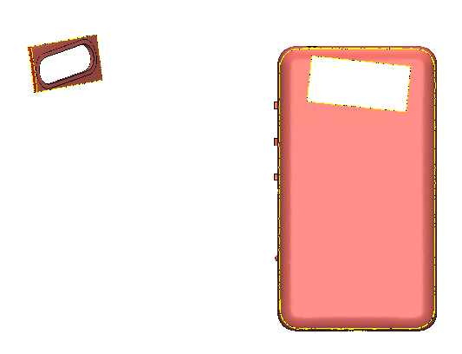

The above phone case is defected. You are required to fix it and extra points will be given for creative designs.

**Challenge 2: Misaligned Hammer**

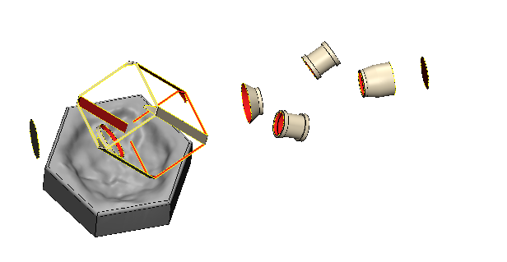

The hammer above is defected and misaligned. Fix it, align it to the base and extra points will be given for creative designs.

**Challenge 3: Design Lamp Shade**

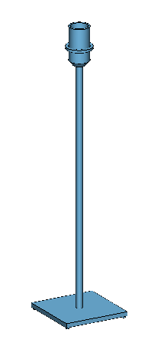

Image above shows a lampstand. You are required to design a lampshade to fit on the stand.

Design specifications:

120mm X 120mm X 200mm

Minimum 2mm thick

At the end of the Hackathon, you will be given 5 minutes to convince the judges, based on your design, why you deserve to win the design challenge.

If you are going to use PowerPoint, please limit your presentation to maximum of 5 slides.

Note: For all 3 questions: Marks will be given based on

* Fixing of defects
* Material optimization
* Printability (All designs should be printable on Formlabs Form2 machine)
* Creativity

Good luck!